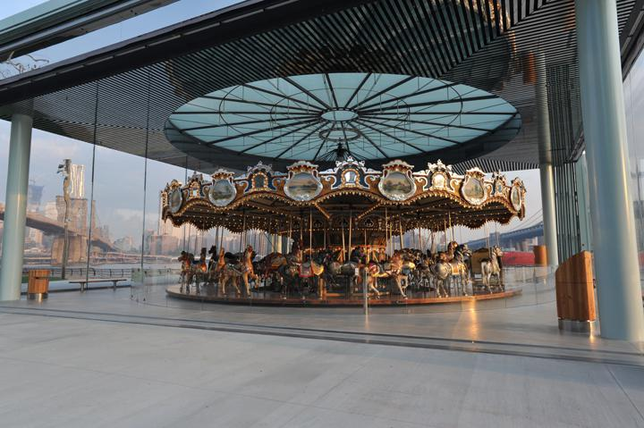

Steel Heavy Corroded

Antique Bronze Darkened

Rust Painted Metal

Bark Pine (SBSAR)

Cork Barriga Waterfall Pattern (SBSAR & SBS)

Glass Scale Formation (SBSAR & SBS)

Gold Natural (SBSAR &SBS)

Koshibo Muslin (SBSAR)

